

AI Based Real -Time Sign Language Recognition and communication System Using OpenCV
A CAPSTONE PROJECT REPORT
A Capstone Project Report submitted in partial fulfilment of the requirements for the Course of
DSA0202 – Computer Vision with OpenCV
to the award of the degree of
BACHELOR OF TECHNOLOGY
IN
ARTIFICIAL INTELLIGENCE AND DATA SCIENCE
Presented by:
P Sai Bhavyatha (192424333)
GUIDE BY:
Dr. Mayuranathan M
SIMATS ENGINEERING
Saveetha Institute of Medical and Technical Sciences
Chennai-602105
SEPTEMBER 2026

BONAFIDE CERTIFICATE
This is to certify that the Capstone Project entitled “AI Based Real -Time Sign Language Recognition and communication System Using open cv” has been carried out by Gopika (192324032), P Sai Bhavyatha (192424333), P Hasini (192424313), S Kamali (192524423) and Dhana Shri (192524422) under the supervision of Dr. Mayuranathan M and is submitted in partial fulfilment of the requirements for the current semester of the Artificial Intelligence and Data Science program at Saveetha Institute of Medical and Technical Sciences, Chennai.
COURSE COORDINATOR COURSE FACULTY
Dr. A. Narenthirakumar Dr. Mayuranathan M
Professor Professor
Dept. of Intelligent Computing Dept. of Cognitive Engineering
SIMATS Engineering SIMATS Engineering
SIMATS, Chennai - 602105 SIMATS, Chennai - 602105

DECLARATION
I, P Sai Bhavyatha (192424333) students of the Department of Artificial Intelligence and Data Science, SIMATS Engineering, Saveetha Institute of Medical and Technical Sciences, Chennai, hereby declare that the Capstone Project Work entitled “AI- Based Real -Time Sign Language Recognition and communication System Using open cv” is the result of our bonafide efforts. To the best of our knowledge, the work presented herein is original, accurate, and has been carried out in accordance with engineering ethics and academic integrity. All sources, references, datasets, software libraries, computational resources and AI-assisted tools used during the project have been appropriately acknowledged. I confirm that the data, results, analysis and findings presented in this report have not been fabricated, falsified or manipulated.

Place: SIMATS Engineering, SIMATS
Date:
Signature

INDIVIDUAL CONTRIBUTION STATEMENT
The project was divided into five connected modules so that each team member had a clearly defined engineering responsibility while contributing to the integrated system.
Student Name / Reg. No. | Specific  Responsibilities | Design & Development  Contribution | Testing & Analysis  Contribution | Report  Contribution | Approx.  Contribution  (%)
S Kamali  (192524423) | Collect ASL images, organize letter-wise folders and maintain the required samples for each supported letter. | Designed the dataset structure, organized the 24 supported static letter classes, prepared landmark data and combined the processed datasets. | Validated sample counts, checked feature dimensions and identified incorrect or incomplete samples. | Documented dataset collection, preprocessing, validation and dataset preparation. | 20%
P Sai Bhavyatha  (192424333) | Perform hand detection and landmark extraction using OpenCV and MediaPipe. | Implemented hand detection, extraction of 21 landmarks, wrist-based normalization and conversion into a 63-feature vector. | Tested landmark detection under different hand positions and verified generated feature vectors. | Documented hand detection, landmark extraction, normalization and feature engineering. | 20%
P Hasini  (192424313) | Develop and train the machine-learning classification model. | Implemented the Random Forest classifier using the extracted 63-feature vectors and corresponding letter labels. | Performed training/testing and evaluated accuracy, precision, recall, F1-score and confusion matrix. | Documented model training, evaluation, results and performance analysis. | 20%
Dhanasri R  (192524343) | Implement real-time sign recognition using webcam input. | Developed the real-time prediction workflow using OpenCV and the trained Random Forest model, including prediction stabilization and no-hand handling. | Tested continuous predictions and checked stability of recognized letters during webcam operation. | Documented real-time recognition, prediction stabilization and testing. | 20%
Gopika J  (192324032) | Develop the communication interface and integrate the complete system. | Designed the communication workflow with Add Letter, Space, Delete and Clear controls, word/sentence construction and Text-to-Speech using pyttsx3. | Tested letter addition, sentence construction, interface controls, speech output and overall module integration. | Documented system integration, communication interface, Text-to-Speech implementation, results and final conclusion. | 20%
Total |  |  |  |  | 100%

All members also participated in integration, testing, debugging, documentation and final presentation preparation.

ABSTRACT
Communication barriers can arise when sign language users interact with people who do not understand sign language. Human interpretation is useful but is not always immediately available, motivating the development of a lightweight real-time recognition system. This capstone presents an AI-based real-time sign language recognition and communication system using OpenCV, MediaPipe and machine learning. The system captures hand images through a webcam and uses MediaPipe Hands to detect a single hand and identify 21 anatomical landmarks. Each landmark contains X, Y and Z coordinates, producing a 63-dimensional feature representation. Wrist-based normalization is applied so that the representation is less dependent on hand position in the camera frame. A Random Forest classifier is trained using labelled ASL landmark data for 24 static letters (A–I and K–Y; J and Z are excluded because they are movement-based signs). The collected dataset contains 2,400 samples, with 100 samples per supported letter. An 80:20 stratified split produces 1,920 training samples and 480 testing samples. In the reported experiment, the Random Forest achieved 100% accuracy on the held-out test split, with precision, recall and F1-score of 1.00 for every supported class and a diagonal confusion matrix. The system then performs continuous webcam inference, stabilizes frame-level predictions using recent prediction history, and displays the recognized letter. The communication module allows users to add letters, insert spaces, delete characters, clear the sentence and convert the constructed text into speech using Text-to-Speech. The result is an integrated proof-of-concept that connects computer vision, landmark-based feature engineering, machine learning and speech synthesis. The 100% test result should be interpreted as performance on the available dataset split; broader real-world generalization requires testing with unseen users, environments and lighting conditions.
Keywords: Sign Language Recognition, ASL, OpenCV, MediaPipe, Hand Landmarks, Random Forest, Machine Learning, Text-to-Speech.

TABLE OF CONTENTS

S.No | Title | Page No
I | Certificate from the Supervisor | ii
Ii | Declaration by the Candidate | iii
Iii | Individual Contribution Statement | iv
Iv | Abstract | v
V | List of Figures | vi
Vi | List of Tables | vi
Vii | List of Abbreviations | vii
1 | CHAPTER 1: Introduction and Engineering Problem | 9
2 | CHAPTER 2: Literature Review and Existing Solutions | 12
3 | CHAPTER 3: Engineering Design & Trade-offs, Sustainability, Ethics,  Safety, Risk & Security | 14
4 | CHAPTER 4: Implementation, Testing & Results, Project Management | 18
5 | CHAPTER 5: Conclusion, Future Work and Reflection | 25
 | References | 26
 | Appendices | 26

LIST OF FIGURES

Figure No. | Figure Name | Page No.
Figure 1 | Overall System Architecture | 11
Figure 2 | Module 1 – Dataset Collection & Preprocessing Workflow | 16
Figure 3 | Module 2 – Hand Detection & Feature Extraction Workflow | 17
Figure 4 | Module 3 – Machine Learning Model Development Workflow | 18
Figure 5 | Module 4 – Real-Time Sign Language Recognition Workflow | 19
Figure 6 | Module 5 – Communication Interface & Text-to-Speech Workflow | 20
Figure 7 | Live Sign Prediction Output | 22
Figure 8 | ASL Confusion Matrix for 24 Static Classes | 22

LIST OF TABLES

Table No. | Table Name | Page No.
Table 1 | Individual Contribution Statement | 4
Table 2 | Dataset Summary | 15
Table 3 | Model Configuration and Test Result | 21
Table 4 | Functional Test Cases | 21
Table 5 | Risk Register | 15
Table 6 | Project Milestone Plan | 24

LIST OF ABBREVIATIONS / SYMBOLS

Symbol | Description | Unit
ASL | American Sign Language | -
AI | Artificial Intelligence | -
CV | Computer Vision | -
TTS | Text-to-Speech | -
RGB | Red, Green, Blue colour representation | -
CSV | Comma-Separated Values | -
RF | Random Forest | -
X, Y, Z | 3D coordinates of each hand landmark | Coordinate values

CHAPTER 1

INTRODUCTION AND ENGINEERING PROBLEM

1.1 Background
Sign language provides a visual means of communication through hand configurations and movements. A practical computer-vision system can reduce the communication gap by translating visible hand signs into machine-readable letters and then into text or speech. The proposed system focuses on static ASL alphabet recognition using a webcam, landmark-based feature extraction and a lightweight machine-learning model.

1.2 Need for the Project
• Communication can be difficult when a sign-language user interacts with a person who does not understand sign language.
• Manual interpretation requires another person and may not be immediately available.
• Real-time recognition requires a fast and compact representation of hand shape.
• Recognized letters must be converted into usable words and sentences rather than being displayed only as isolated predictions.
• A complete prototype should connect image capture, hand detection, classification and communication output in one workflow.

1.3 Problem Statement
There is a need for an automated system that can detect a hand from live webcam input, recognize supported ASL alphabet signs with low computational overhead, stabilize frame-by-frame predictions and convert recognized letters into meaningful text and speech. Existing communication often depends on human interpretation or systems that are limited to isolated recognition without an integrated communication interface.

1.4 Project Aim
To design and implement an AI-based real-time sign language recognition and communication system that detects hand landmarks, classifies static ASL letters and converts the recognized sequence into text and speech.

1.5 Project Objectives
• Collect and preprocess ASL sign-language images for the supported static alphabet.
• Detect hands using MediaPipe and OpenCV.
• Extract and normalize 21 hand landmarks.
• Generate a 63-feature vector from X, Y and Z landmark coordinates.
• Train and evaluate a Random Forest classifier.
• Perform continuous real-time recognition through a webcam.
• Provide controls for adding letters, spacing, deleting and clearing text.
• Convert the final communication text into speech using Text-to-Speech.

1.6 Scope
The current prototype covers 24 static ASL letters: A, B, C, D, E, F, G, H, I, K, L, M, N, O, P, Q, R, S, T, U, V, W, X and Y. J and Z are not part of the current static model because their ASL forms depend on movement. The system is designed for webcam-based recognition and communication rather than full sentence-level sign-language translation.

1.7 Expected Engineering Outcome
• A validated landmark dataset with 2,400 samples and 63 numerical features plus a label.
• A trained Random Forest model saved for inference.
• A real-time recognition pipeline with prediction stabilization.
• A communication interface for constructing text.
• Text-to-Speech output for the constructed sentence.

SYSTEM ARCHITECTURE
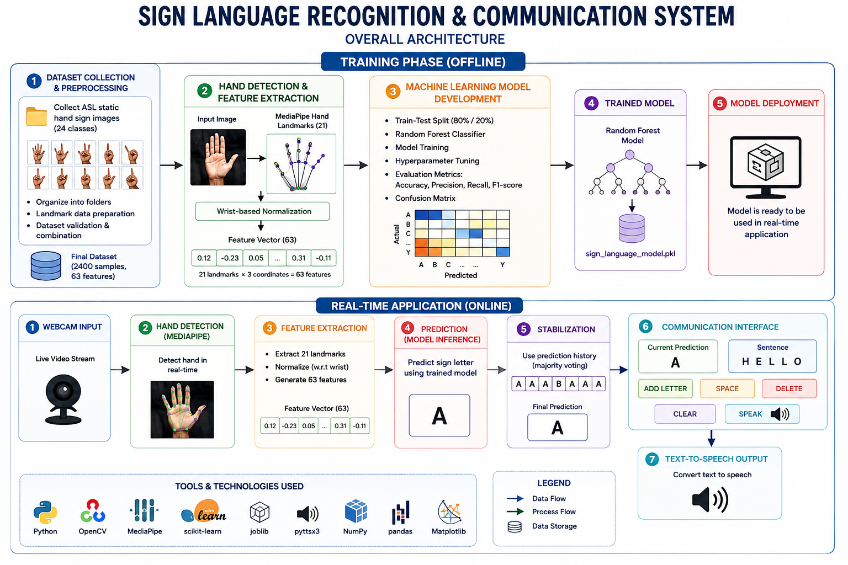
Figure No. 1.1 - Overall System Architecture
The architecture connects the five modules in sequence. Dataset preparation produces normalized landmark features; hand detection and feature extraction create the same 63-feature representation during live inference; the Random Forest model performs classification; the real-time module stabilizes predictions; and the communication module converts selected letters into text and speech.

CHAPTER 2

LITERATURE REVIEW AND EXISTING SOLUTIONS

2.1 Review Method
The review focused on research and practical implementations involving MediaPipe hand landmarks, machine-learning classification, real-time sign-language recognition and communication interfaces. The selected references in the project presentation were used to understand the suitability of landmark-based recognition and lightweight classifiers.

2.2 Review of Existing Work
Khatavkar et al. describe a real-time sign-language recognition approach using MediaPipe hand landmarks and a Random Forest classifier, supporting the use of lightweight landmark features for fast recognition. Shri Sudarsana et al. similarly discuss real-time sign-to-text conversion using normalized MediaPipe landmarks and Random Forest. Pranav et al. investigate MediaPipe with LSTM for ASL alphabet recognition, highlighting the relevance of landmark representations for both static and dynamic signs. Varanasi et al. examine isolated sign-language recognition using MediaPipe landmarks with broader hand, face and pose information.

2.3 Comparative Analysis
Table No. -2.1 – COMPARITIVE ANALYSIS
Approach | Advantages | Limitations | Relevance
Image-based deep learning | Can learn visual appearance directly | Higher computation and larger data requirements | Useful for future expansion
MediaPipe + Random Forest | Lightweight, interpretable and fast | Depends on reliable landmark detection | Selected for the current prototype
MediaPipe + LSTM | Suitable for temporal/dynamic gestures | More complex and needs sequence data | Potential future approach for J/Z and words
Manual interpretation | Can understand context and continuous signing | Requires a human interpreter | Problem the system aims to reduce

2.4 Research / Engineering Gap
A major practical gap is not only recognizing a hand sign, but connecting recognition to an interactive communication workflow. The project therefore integrates hand detection, feature engineering, classification, prediction stabilization and text-to-speech rather than stopping at a single predicted label.

2.5 Proposed Contribution
The proposed contribution is a compact end-to-end prototype that uses normalized 21-point hand landmarks as a common representation across dataset generation and live inference. A Random Forest model is used for static letter recognition, while a simple communication interface allows recognized letters to be assembled into words and sentences.

CHAPTER 3

ENGINEERING DESIGN & TRADE-OFFS, SUSTAINABILITY, ETHICS, SAFETY, RISK & SECURITY

3.1 Requirements
The main stakeholders are sign-language users, communication partners, student developers and evaluators. The system requirements are:
• Capture live webcam frames using OpenCV.
• Detect a single hand using MediaPipe Hands.
• Extract 21 landmarks and produce 63 normalized numerical features.
• Classify the feature vector into one of the 24 supported static classes.
• Stabilize predictions across multiple frames.
• Provide communication controls for Add Letter, Space, Delete, Clear and Speak.
• Operate on a normal laptop/desktop without specialized hardware.

3.2 Constraints & Applicable Considerations
• The system depends on webcam quality and environmental lighting.
• MediaPipe must successfully detect the hand for classification.
• Only static signs are currently modelled; J and Z require movement-based recognition.
• The classifier is trained on a finite dataset and may not generalize equally to unseen users.
• The communication output should be treated as assistive output, not guaranteed semantic translation.

3.3 Design Specifications
Table No-3.1-Design Specifications
Parameter | Specification | Priority
Input | Webcam video frames | High
Hand detector | MediaPipe Hands, max one hand | High
Landmarks | 21 landmarks × X,Y,Z = 63 features | High
Normalization | Wrist-based subtraction | High
Classifier | Random Forest, 300 trees | High
Classes | 24 static ASL letters | High
Stabilization | Recent prediction history, most frequent class | Medium
Communication | Letter accumulation + controls + TTS | High

3.4 Alternative Solutions & Evaluation
• Alternative 1 – Image CNN: potentially strong visual learning, but heavier training and inference requirements.
• Alternative 2 – Sequence LSTM: better suited to dynamic signs, but requires temporal training data and more implementation complexity.
• Alternative 3 – MediaPipe landmarks + Random Forest: compact features, fast inference and straightforward integration with OpenCV; selected for the present static-sign prototype.

3.5 Selected Design & Detailed Design
The selected pipeline is: Webcam Input → MediaPipe Hand Detection → 21 Landmark Extraction → Wrist-Based Normalization → 63-Feature Vector → Random Forest Prediction → Prediction Stabilization → Communication Interface → TTS.

3.6 Trade-off Analysis
The main trade-off is between recognition simplicity and sign-language coverage. A 63-feature landmark vector is much smaller than raw images and supports fast Random Forest inference, but it does not directly represent the temporal motion needed for dynamic signs. The system therefore prioritizes reliable static-letter recognition and a usable communication interface within the project's current scope.

3.7 Sustainability, Ethics, Safety, Risk & Security
Table No-3.2- Sustainability, Ethics, Safety, Risk & Security
Risk | Likelihood | Severity | Mitigation | Residual Risk
Poor lighting / background | High | Medium | Use varied training images and stable framing | Medium
Hand not detected | Medium | Medium | Display No Hand and clear prediction history | Low
Similar hand shapes | Medium | High | Use normalized landmarks and prediction stabilization | Medium
Dataset bias | Medium | High | Expand users, orientations and environments in future | Medium
Incorrect speech output | Low | High | Require user selection of letters and explicit Speak action | Low

The system is intended as an assistive prototype. Privacy should be considered when using webcam input, and user images should not be retained unnecessarily. The model should not be presented as a full substitute for human interpreters or as a complete translation of natural sign language.

CHAPTER 4

IMPLEMENTATION, TESTING & RESULTS, PROJECT MANAGEMENT

4.1 Development Approach & Resources
The implementation follows a modular approach. The first module prepares the labelled landmark dataset. The second module defines the hand-detection and feature representation used during inference. The third module trains and evaluates the Random Forest classifier. The fourth module performs real-time recognition and prediction stabilization. The fifth module integrates the recognized letters into a communication interface and adds Text-to-Speech output.

4.2 Module 1 – Dataset Collection & Preprocessing
Static ASL images are organized into separate letter folders. MediaPipe extracts 21 hand landmarks from each image, and the landmark coordinates are stored as numerical features with the corresponding label. The final combined dataset contains 2,400 samples, 63 features and one class label.
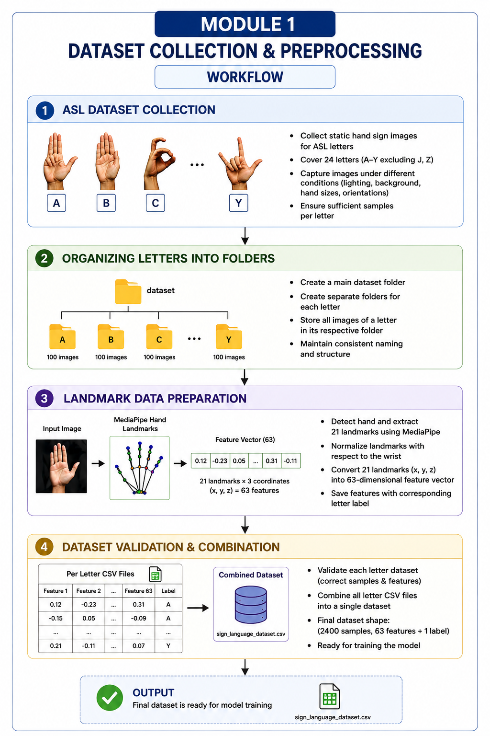
Figure No. 4.1: Module 1 – Dataset Collection & Preprocessing Workflow

4.3 Module 2 – Hand Detection & Feature Extraction
OpenCV captures the webcam frame and converts it from BGR to RGB before MediaPipe processing. MediaPipe identifies 21 hand landmarks. For each landmark, the wrist landmark (landmark 0) is subtracted from X, Y and Z so that the feature representation is less dependent on the absolute hand position. The resulting 21 × 3 values form the 63-dimensional vector passed to the classifier.
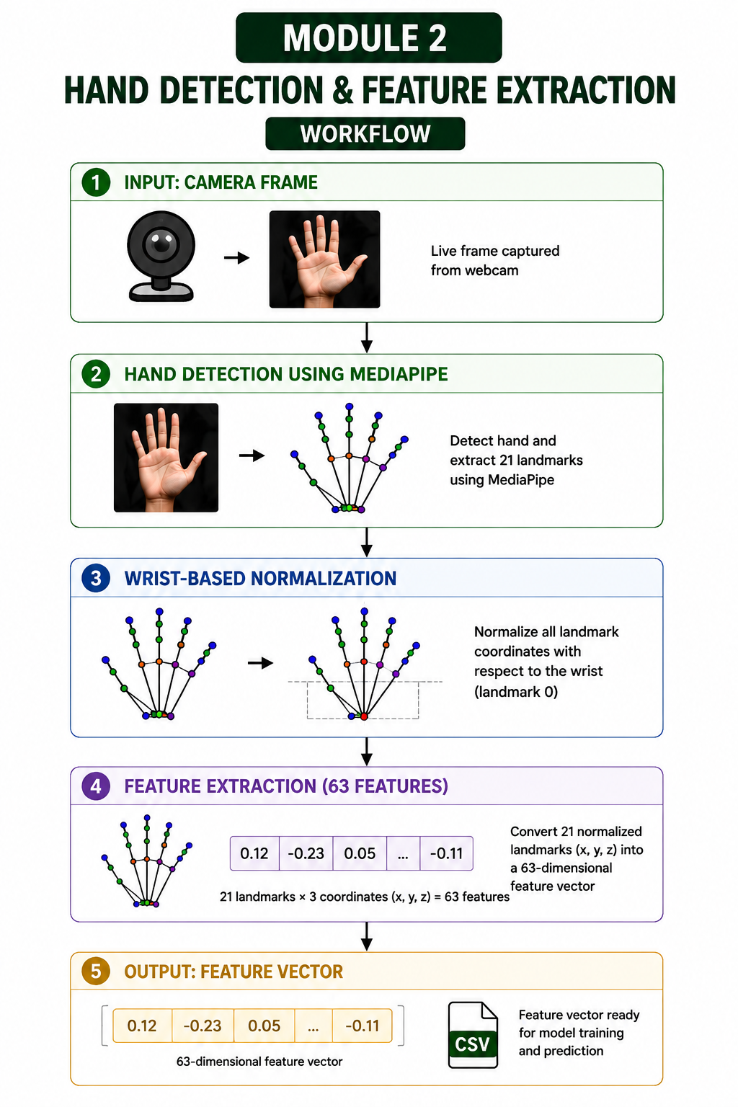
Figure No. 4.2: Module 2 – Hand Detection & Feature Extraction Workflow

4.4 Module 3 – Machine Learning Model Development
The combined dataset is divided into training and testing data using an 80:20 stratified split. A Random Forest classifier with 300 estimators, balanced class weights and a fixed random state is trained on the 1,920 training samples. The 480 test samples are then classified to obtain objective performance measurements.
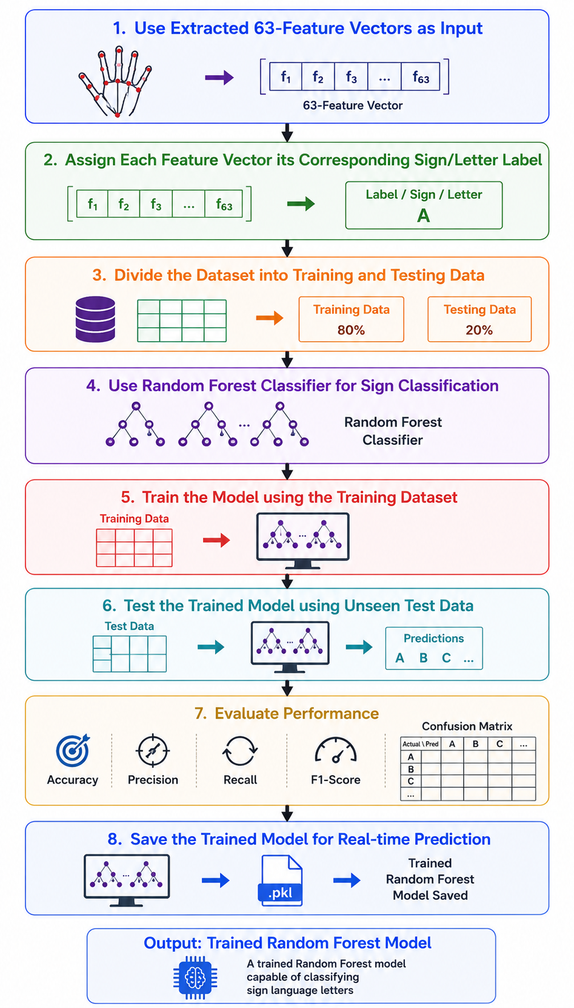
Figure No.4.3: Module 3 – Machine Learning Model Development Workflow

4.5 Module 4 – Real-Time Sign Language Recognition
The trained model is loaded and applied continuously to webcam frames. Each detected hand is converted into the same 63-feature representation used during training. Recent predictions are stored in a short history buffer, and the most frequent prediction is used as the stabilized output. If no hand is detected, the prediction is reset to No Hand and the history is cleared.
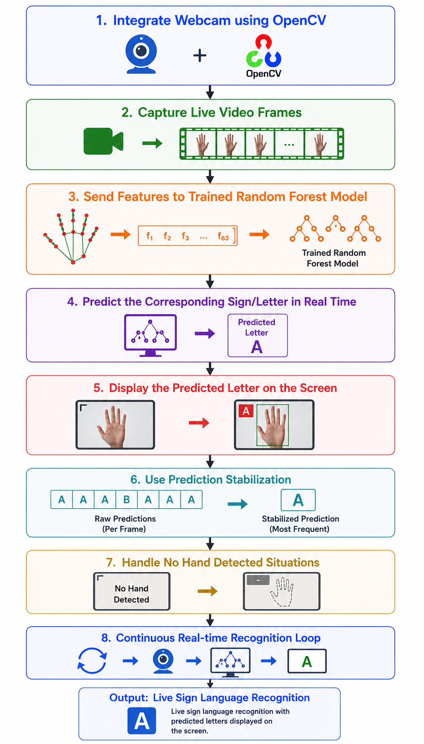
Figure No.4.4: Module 4 – Real-Time Sign Language Recognition Workflow

4.6 Module 5 – Communication Interface & Text-to-Speech
The communication interface displays the current recognized letter and the constructed sentence. The user can explicitly add the current letter, insert a space, delete the last character, clear the sentence or activate speech. The final text is passed to the pyttsx3 Text-to-Speech engine, providing an audible communication output.
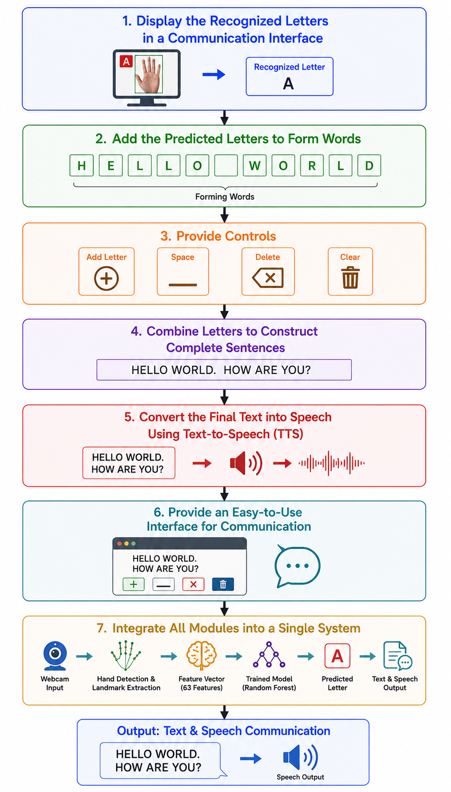
Figure No.4.5: Module 5 – Communication Interface & Text-to-Speech Workflow

4.7 Test Plan & Verification
Table No.4.1- Test Plan & Verification
Test Case | Method | Expected Result | Observed Result
Dataset loading | Load combined CSV | 2,400 samples and 64 columns | Passed
Feature count | Inspect model input | 63 features | Passed
Class coverage | Count unique labels | 24 static classes | Passed
Train/test split | Stratified 80:20 split | 1,920 / 480 | Passed
Model training | Fit Random Forest | Model trains successfully | Passed
Classification | Predict 480 test samples | Correct class prediction | 100% accuracy reported
Live detection | Webcam + MediaPipe | 21 landmarks visible | Passed
Communication | Add/space/delete/clear/speak | Sentence manipulation and TTS | Implemented

4.8 Results
Table No.4.2-Results
Metric | Result
Dataset size | 2,400 samples
Features | 63 numerical features + 1 label
Classes | 24
Samples per class | 100
Training samples | 1,920
Testing samples | 480
Classifier | Random Forest
Accuracy | 100.00%
Precision | 1.00 for every class
Recall | 1.00 for every class
F1-score | 1.00 for every class

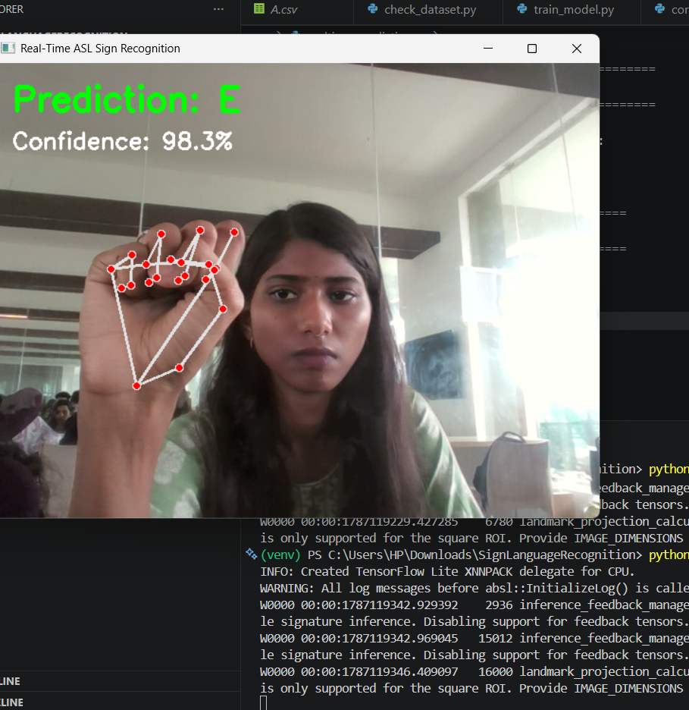
Figure No.4.6: Live Sign Prediction Output
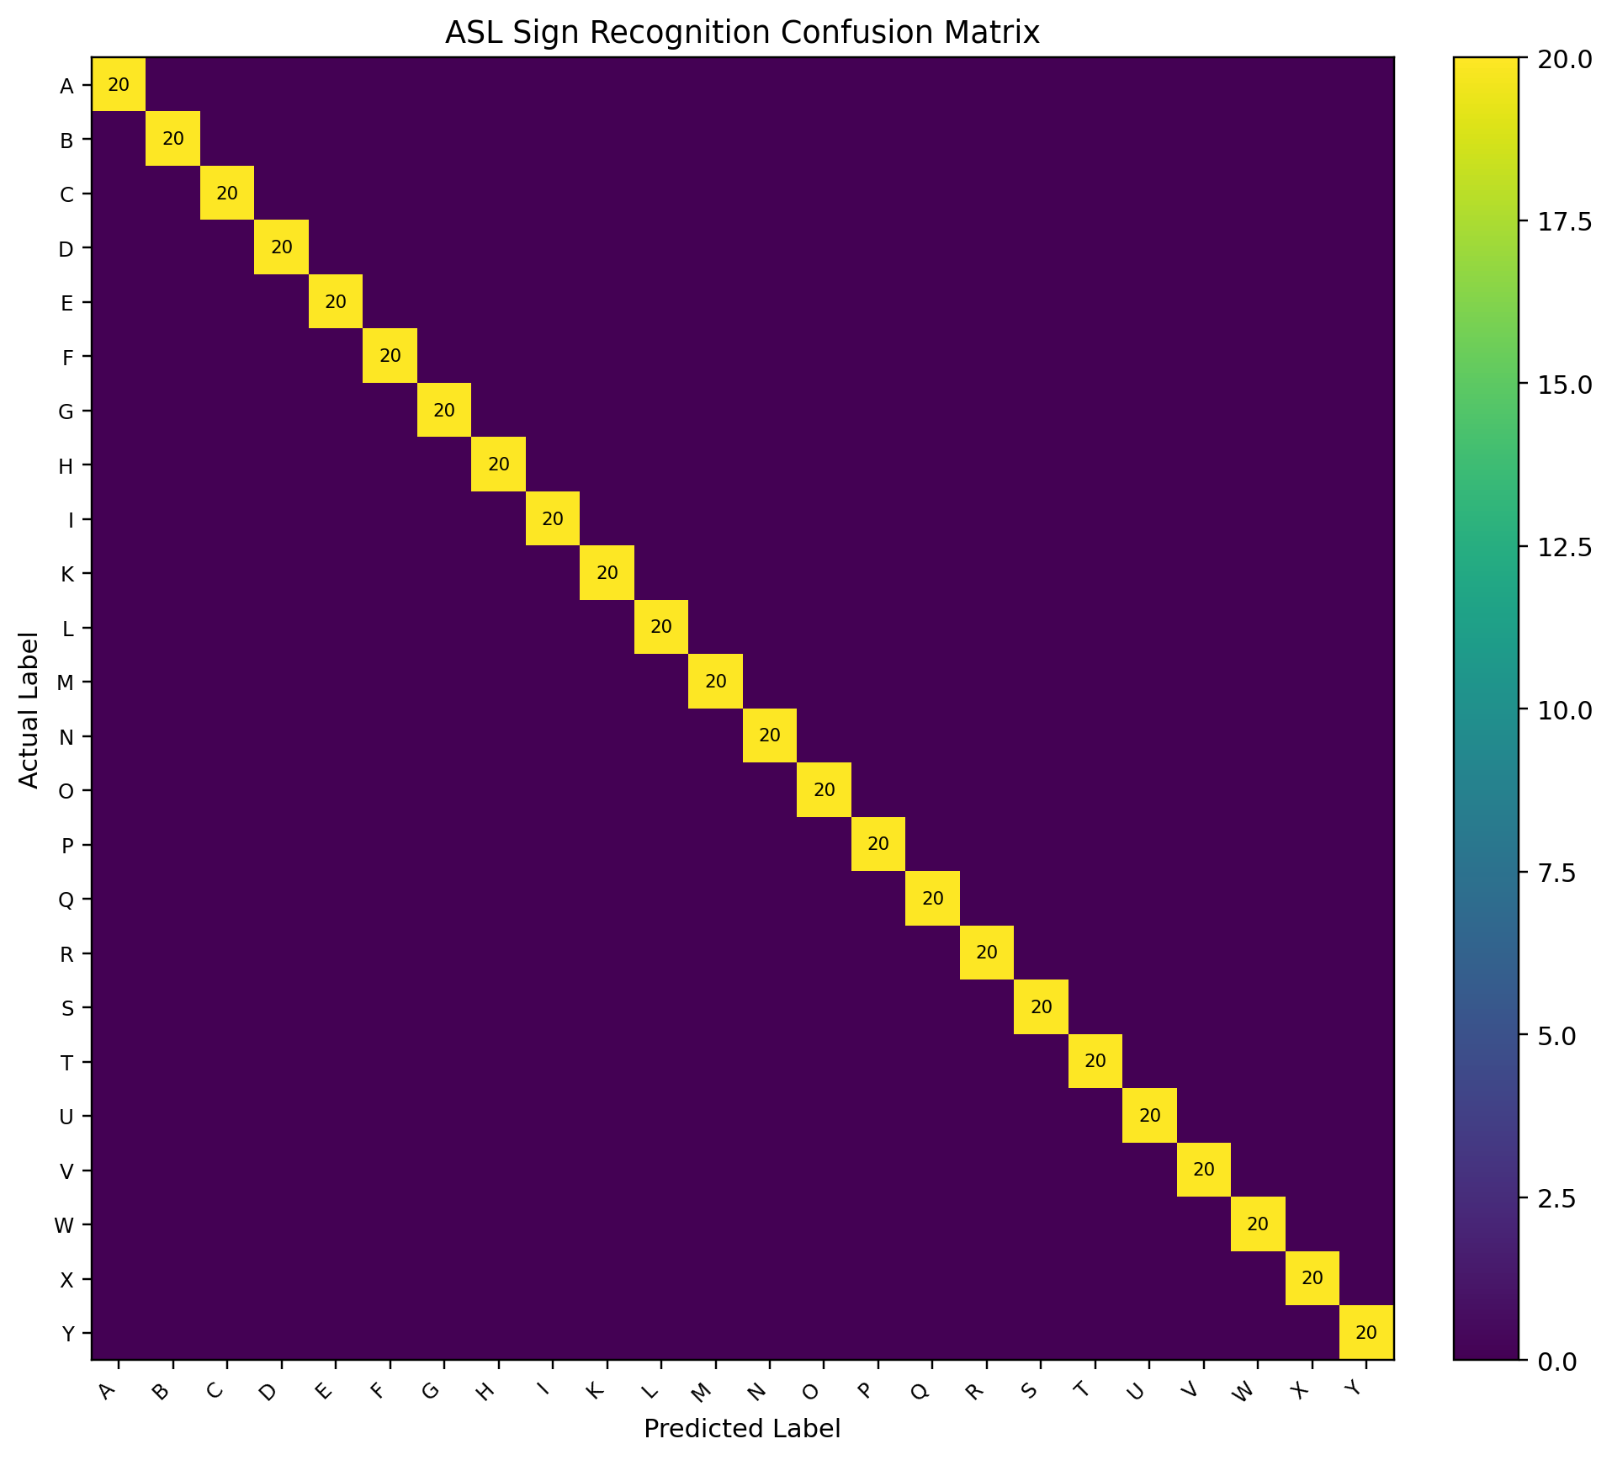
Figure No.4.7: ASL Confusion Matrix for 24 Static Classes

4.9 Data Analysis & Engineering Judgment
The reported 100% accuracy is internally consistent with the supplied confusion matrix: every one of the 24 classes has 20 correct predictions and zero off-diagonal errors in the 480-sample test split. This demonstrates that the current dataset is highly separable for the selected model. However, a perfect score on a held-out portion of the same collected dataset does not prove perfect performance in real-world conditions. The next meaningful validation step is a user-independent test set containing people, lighting conditions, backgrounds and hand orientations not represented in training.

4.10 Strengths & Limitations
• Strengths: lightweight landmark representation, fast Random Forest inference, simple webcam integration, prediction stabilization and integrated TTS communication.
• Strengths: clear separation of dataset preparation, feature extraction, model training, real-time recognition and communication.
• Limitations: only 24 static letters are currently recognized; J and Z are excluded because they are movement-based.
• Limitations: performance depends on MediaPipe hand detection and camera/environment conditions.
• Limitations: the current model does not understand complete sign-language grammar, context or continuous sentence-level gestures.

4.11 Hardware / Software / Modern Tools Used

Table No.4.3- Hardware / Software / Modern Tools Used
Tool / Technology | Purpose
Python | Main programming language
OpenCV | Webcam capture, frame processing and interface rendering
MediaPipe Hands | Hand detection and 21-landmark extraction
NumPy | Numerical feature processing
Pandas | Dataset loading and validation
scikit-learn | Random Forest model and evaluation
Joblib | Model persistence
pyttsx3 | Text-to-Speech output
VS Code | Development environment
Webcam | Live image acquisition

4.12 Project Planning, Roles & Budget
Table No.4.4- Project Planning, Roles & Budget
Phase | Activity | Responsible Member(s)
Phase 1 | Problem definition and planning | All members
Phase 2 | Dataset collection and preprocessing | S Kamali
Phase 3 | Hand detection and feature extraction | P Sai Bhavyatha
Phase 4 | Model training and evaluation | P Hasini
Phase 5 | Real-time recognition | Dhanasri R
Phase 6 | Communication interface and TTS | Gopika
Phase 7 | Integration, testing and documentation | All members

Item | Estimated Cost | Actual Cost
Existing laptop/desktop | Existing resource | No additional cost
Webcam | Existing / low-cost | No additional project cost
Python and open-source libraries | Free | Free
Dataset preparation | Existing resources | No additional project cost
Total | Low-cost software prototype | No major additional cost

The project is primarily software-based and uses open-source Python libraries. This keeps the prototype inexpensive and reduces dependence on specialized hardware.

CHAPTER 5

CONCLUSION, FUTURE WORK AND REFLECTION

5.1 Conclusion
• The system successfully demonstrates real-time ASL static-letter recognition using computer vision and machine learning.
• OpenCV and MediaPipe provide webcam integration, hand detection and extraction of 21 hand landmarks.
• The normalized 63-feature representation provides a compact input to the Random Forest classifier.
• The reported test result reached 100% accuracy on 480 held-out samples from the current 2,400-sample dataset.
• The communication module combines selected letters into text and provides Text-to-Speech output, completing the end-to-end communication workflow.
Overall, the project demonstrates how computer vision, landmark-based feature engineering, machine learning and speech synthesis can be integrated into a practical assistive communication prototype.

5.2 Future Enhancements
• Extend the system to dynamic ASL signs, including J and Z, using temporal models such as LSTM or other sequence-based approaches.
• Expand recognition from individual letters to complete words and commonly used sign-language phrases.
• Improve robustness under different lighting conditions, backgrounds, camera angles and hand orientations.
• Add voice-to-text and text-to-sign capabilities for two-way communication.
• Develop a mobile or web-based application for more portable real-time communication.

5.3 Professional Learning & Individual Reflection
My contribution to the project helped me gain practical experience in real-time sign language recognition using OpenCV and Random Forest. I learned to integrate machine-learning models with webcam input, improve prediction stability, handle no-hand conditions, and test the system for reliable real-time performance. This project strengthened my computer vision, debugging, testing, and problem-solving skills and improved my understanding of developing practical AI-based applications.

Student | Reflection / Learning
P Sai Bhavyatha  (192424333) | Gained practical experience in real-time sign language recognition using OpenCV and Random Forest, and improved my skills in image preprocessing, feature extraction, machine-learning model integration, testing, and debugging for developing an effective communication system.

REFERENCES
[1] Zhang, F., Bazarevsky, V., Vakunov, A., Tkachenka, A., Sung, G., Chang, C.-L., & Grundmann, M. (2020). MediaPipe Hands: On-device Real-time Hand Tracking. CVPR Workshop / arXiv.
[2] Bazarevsky, V., & Zhang, F. (2019). On-Device, Real-Time Hand Tracking with MediaPipe. Google Research.
[3] Bradski, G. (2000). The OpenCV Library. Dr. Dobb's Journal of Software Tools.
[4] Breiman, L. (2001). Random Forests. Machine Learning, 45, 5–32. https://doi.org/10.1023/A:1010933404324.
[5] Pedregosa, F., Varoquaux, G., Gramfort, A., et al. (2011). Scikit-learn: Machine Learning in Python. Journal of Machine Learning Research, 12, 2825–2830.
[6] Harris, C. R., Millman, K. J., van der Walt, S. J., et al. (2020). Array Programming with NumPy. Nature, 585, 357–362. https://doi.org/10.1038/s41586-020-2649-2.
[7] McKinney, W. (2022). Python for Data Analysis: Data Wrangling with pandas, NumPy, and Jupyter (3rd ed.). O'Reilly Media.
[8] OpenCV Documentation. OpenCV-Python Tutorials and Computer Vision Documentation.
[9] NumPy Documentation. NumPy User Guide and Reference Documentation.
[10] pandas Documentation. pandas User Guide and API Reference.
[11] Joblib Documentation. Persistence and Model Serialization Documentation.
[12] pyttsx3 Documentation. Text-to-Speech x-platform Documentation.

APPENDICES

Appendix A – Detailed Calculations
A.1 Number of features: 21 landmarks × 3 coordinates (X, Y, Z) = 63 features.
A.2 Training samples: 2,400 × 0.80 = 1,920 samples.
A.3 Testing samples: 2,400 × 0.20 = 480 samples.
A.4 Samples per class: 100 samples × 24 classes = 2,400 samples.
A.5 Accuracy = Correct Predictions / Total Test Samples × 100 = 480 / 480 × 100 = 100%.
A.6 For every class, Precision = 1.00, Recall = 1.00 and F1-score = 1.00 in the supplied test report.

Appendix B – Engineering Drawings / Schematics

Appendix Figure B1: Overall System Architecture
Appendix C – Source Code / Code Repository Information
The implemented project is organized around the following scripts. The snippets below document the core engineering operations used by the system.
File | Role
check_dataset.py | Checks expected static letters, sample counts, feature columns and creates the combined CSV.
extract_landmarks.py | Captures webcam frames and extracts the 21 MediaPipe landmarks.
hand_detection.py | Demonstrates MediaPipe hand detection and landmark drawing.
train_model.py | Supports model loading/inference and prediction stabilization in the current project workflow.
realtime_prediction.py | Runs real-time model prediction from webcam input.
communication.py | Provides letter accumulation, editing controls and Text-to-Speech communication.
confusion_matrix.py | Trains Random Forest on the dataset and generates the confusion matrix.

Representative Landmark Extraction
rgb_frame = cv2.cvtColor(frame, cv2.COLOR_BGR2RGB)
results = hands.process(rgb_frame)
if results.multi_hand_landmarks:
hand_landmarks = results.multi_hand_landmarks[0]
landmarks = []
for landmark in hand_landmarks.landmark:
landmarks.extend([landmark.x, landmark.y, landmark.z])

Representative Wrist-Based Normalization
wrist = hand_landmarks.landmark[0]
for landmark in hand_landmarks.landmark:
x = landmark.x - wrist.x
y = landmark.y - wrist.y
z = landmark.z - wrist.z
landmarks.extend([x, y, z])

Representative Random Forest Training
model = RandomForestClassifier(
n_estimators=300,
random_state=42,
class_weight="balanced",
n_jobs=-1
)
model.fit(X_train, y_train)
y_pred = model.predict(X_test)

Appendix D – Datasheets / Tools and Technologies
Technology | Application in Project
Python | Core implementation language
OpenCV | Webcam capture, image conversion, display and interface controls
MediaPipe Hands | 21-point hand landmark detection
NumPy | Landmark array and numerical feature processing
Pandas | CSV loading, validation and dataset combination
scikit-learn | Random Forest classification and evaluation
joblib | Saving/loading the trained model
pyttsx3 | Text-to-Speech output
VS Code | Programming and debugging environment
CSV | Storage of extracted landmark feature vectors and labels

The implementation uses commonly available Python libraries and does not require a cloud service for the core recognition pipeline. This supports a low-cost, locally executed prototype.

Appendix E – Experimental / Raw Data

E.1 Dataset Testing
• All supported static letters were present: A–I and K–Y, excluding J and Z.
• Each supported class contained 100 samples.
• Combined dataset size was 2,400 samples.
• The combined CSV contained 64 columns: 63 feature values and one label.
• The stratified test set contained 480 samples, 20 per class.

E.2 Model Testing
• Random Forest training completed successfully.
• All 480 test samples were correctly classified in the supplied result.
• No off-diagonal entries occurred in the supplied 24-class confusion matrix.
• Accuracy, precision, recall and F1-score were all reported as 100% / 1.00.

E.3 Real-Time Testing
• Webcam frames were captured using OpenCV.
• MediaPipe displayed the 21 hand landmarks.
• The model accepted a 63-feature input vector.
• Prediction history was used to stabilize the displayed class.
• No-hand situations cleared the prediction history.

Appendix F – Ethics / Safety / Privacy

1. Data Privacy
Webcam frames and collected images should be used only for the intended recognition workflow and should not be retained unnecessarily.

2. Dataset Responsibility
Training data should represent different users and conditions to reduce bias and improve robustness.

3. AI Output Safety
A predicted letter is an automated classification and can be wrong; the communication interface therefore requires user selection before adding a letter.

4. Speech Output
Text-to-Speech should only be activated for the text intentionally constructed by the user.

5. Accessibility
The interface should use clear controls and readable output so that the final communication workflow remains practical.
Appendix G – Project Meeting / Progress Records
• Project topic finalized.
• Problem statement and objectives identified.
• ASL dataset collection completed for 24 static letters.
• Landmark extraction and normalization implemented.
• Combined dataset validated.
• Random Forest model trained and evaluated.
• Real-time prediction implemented.
• Communication interface and Text-to-Speech integrated.
• Testing, screenshots, workflow diagrams and final documentation completed.

CAPSTONE PROJECT OUTCOME MAPPING SHEET
Outcome Evidence | SO / Area | Location in This Report
Complex engineering problem formulation | SO1 | Ch. 1, Ch. 2
Engineering design under constraints | SO2 | Ch. 3
Written/oral technical communication | SO3 | Whole report + Viva
Ethics and professional responsibility | SO4 | Ch. 3 (3.7)
Teamwork and leadership | SO5 | Ch. 4 (4.8)
Experimentation, analysis, and engineering judgment | SO6 | Ch. 4 (4.3–4.6)
Independent acquisition of new knowledge | SO7 | Ch. 5 (5.3)
Standards and technical principles | SO2 | Ch. 3 (3.2)
Sustainability and societal impact | SO2/ SO4 | Ch. 3 (3.7)
Risk assessment and mitigation | SO2/SO4 | Ch. 3 (3.7)
Security and privacy considerations | Relevant SO | Ch. 3 (3.7)
Integrated/system-level engineering | SO1/SO2 | Ch. 3 (3.5)
Graph metrics and centrality analysis | SO1/SO2/SO6 | Ch. 3 (3.5), Ch. 4 (4.4–4.6)
Graph-theoretic relational analysis | SO1/SO6 | Ch. 3 (3.5), Ch. 4 (4.4–4.6)
AI-based misinformation analysis | SO1/SO2/SO6 | Ch. 3 (3.5), Ch. 4 (4.4–4.6)
Project planning and management | SO5 | Ch. 4 (4.8)
Individual contribution | SO1-SO7 | Contribution Statement + Ch. 4 (4.8)
Table : Mapping with CO’S

The project demonstrates integration of computer vision, machine learning, feature engineering, software implementation, testing and communication-oriented system design.

